**INTERNSHIP REPORT**

**ON**

# PYTHON COMPITATIVE CODEING

**A internship Report is submitted**

**In accordance with requirement of degree of**

**BACHELOR OF TECHNOLOGY IN**

**Computer science and information technology**

Submitted by

I.TEJASWINI

21KQ1A0710

Under the Mentorship of

## M.SHRAVAN KUMAR



**DEPARTMENT OF Computer science and information technology**

PACE INSTITUTE OF TECNOLOGY AND SCIENCES

(AUTONOMOUS) (Affiliated to Jawaharlal Nehru Technological University Kakinada, Kakinada & Accredited by NAAC ‘A’ GRADE,An ISO 9001-2015 Certified Institution)

NH-16, Valluru Post , Prakasam District, A.P-5232721

CAMPUS CHOICE PREDICTOR

DESCRIPITION:

Campus choice predictor is the process to choose the campus based on their requirments. Students gather the information about the college based on academic performance,placements,schemes,facilites provided by the college. Enquiring about the college from others. Few are thinking about the college near to native place. Few people thinks about the fees structure whether it is affordable or not. Some people thinks about the autonomous college or not. Some body thinks about the others opinion.This project is about finding the best college.

Requirements:

INPUT:

1.College name

2. List of Branches in college

3.No.of placements

4.Pass percentage

5.Distance

6.Status

7.Transport

OUTPUT:

1.Details of particular college

2.College name with placements greater than 500

3.Transport available college names

4.No.of autonomous colleges

5.Branches of particular college

6.College that are less distance

7.college names with pass percentage greater than 60

8.Which college has max placements

FUNCTIONS:

-Conditions,Lists,Sets,Dictionary,max(),pandas

APPROACH:-

1.UserInput:

The code allows users to enter information for a specified number of colleges. College details include name, branches (as a list), placements, percentage, distance, status (autonomous/non-autonomous), and transport availability.

 2. Data Storage and Display:

It stores the entered data in a list of dictionaries (l). The code displays the college details in a tabular format.

3. DataFrame Creation:

It creates a Pandas DataFrame (df) from the list l

 4. College Search:

It allows users to search for a specific college by name and displays its details.

 5. Filtering:

It can filter colleges based on:

Placements greater than 500 Transport availability ("yes") Percentage greater than 60 Autonomous status ("autonomous")

source code:-

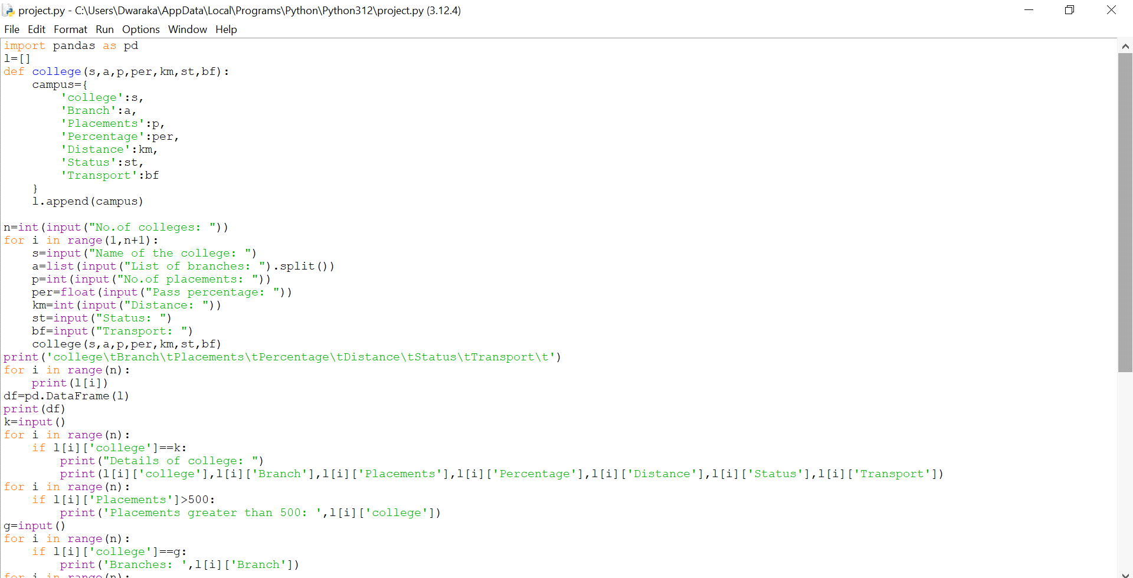

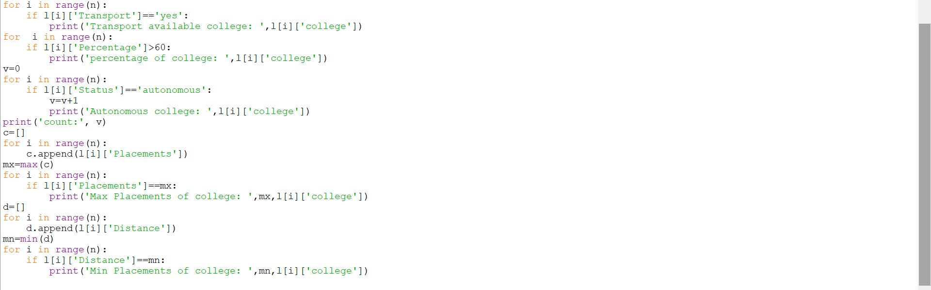

Output:

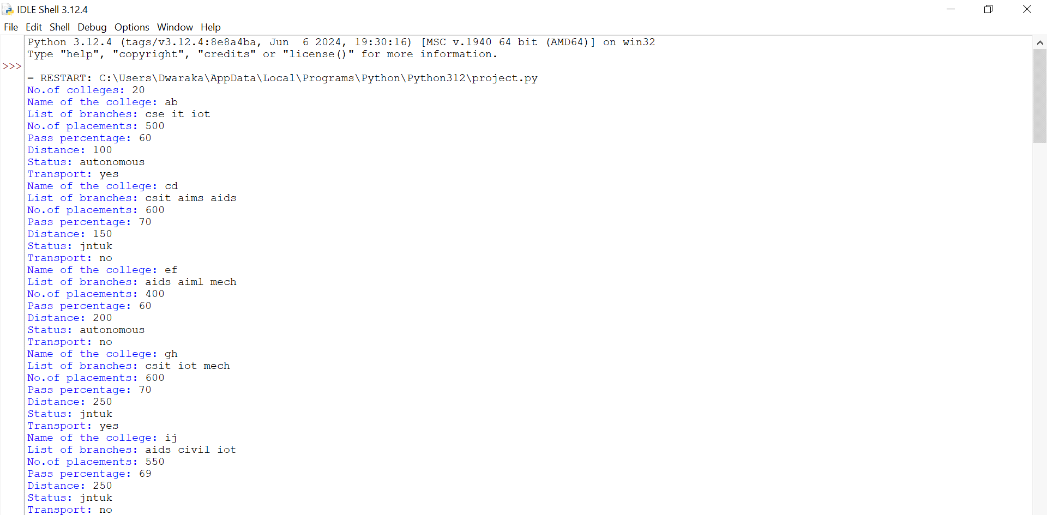

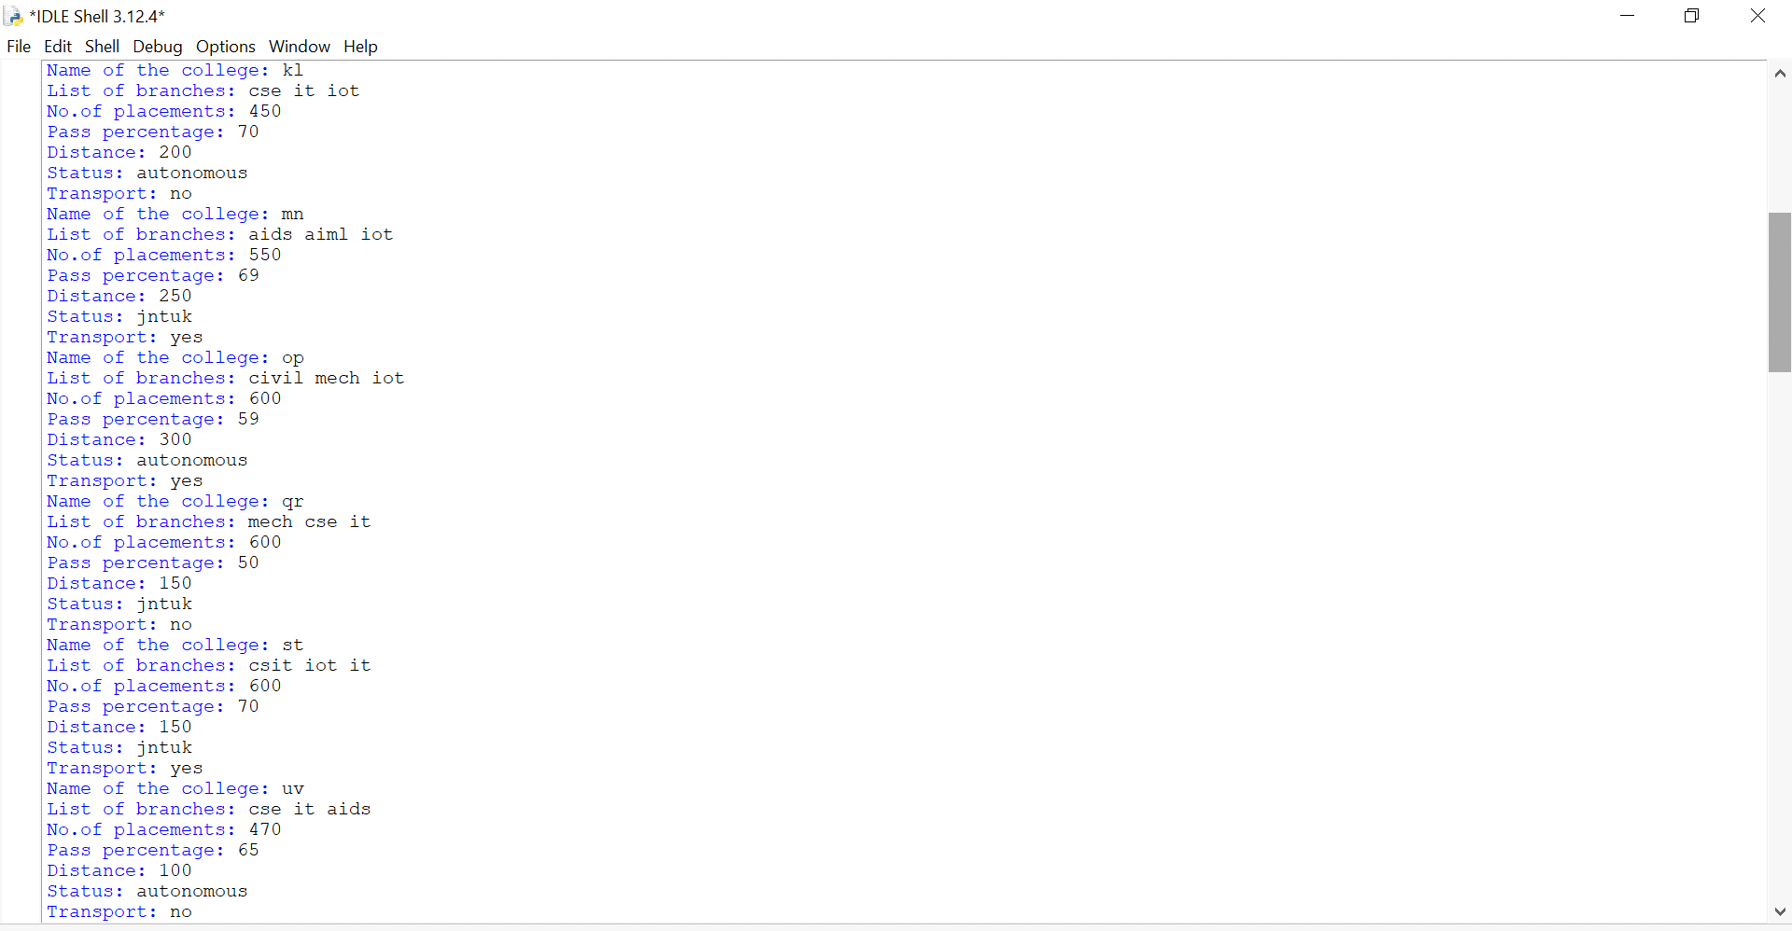

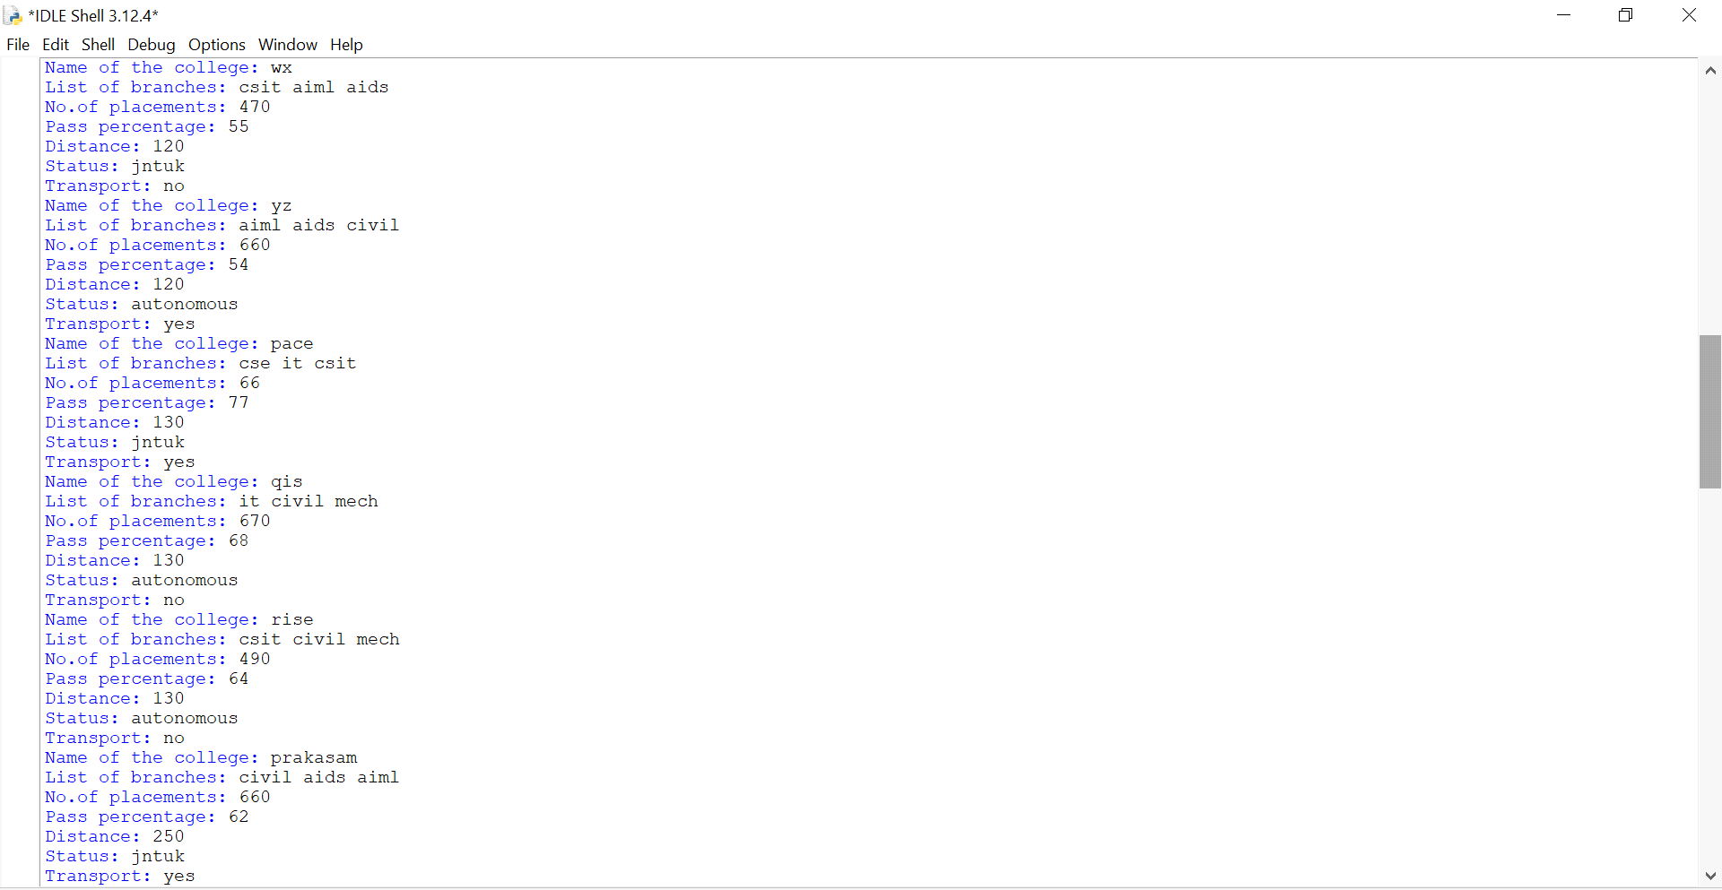

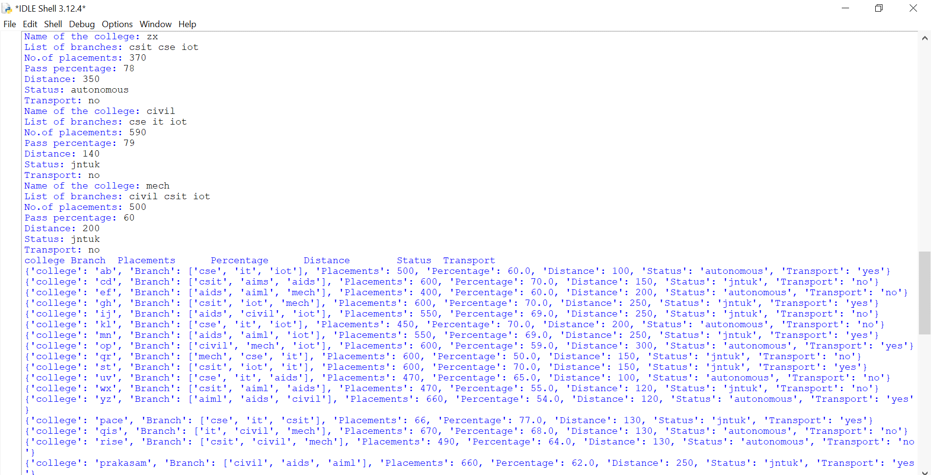

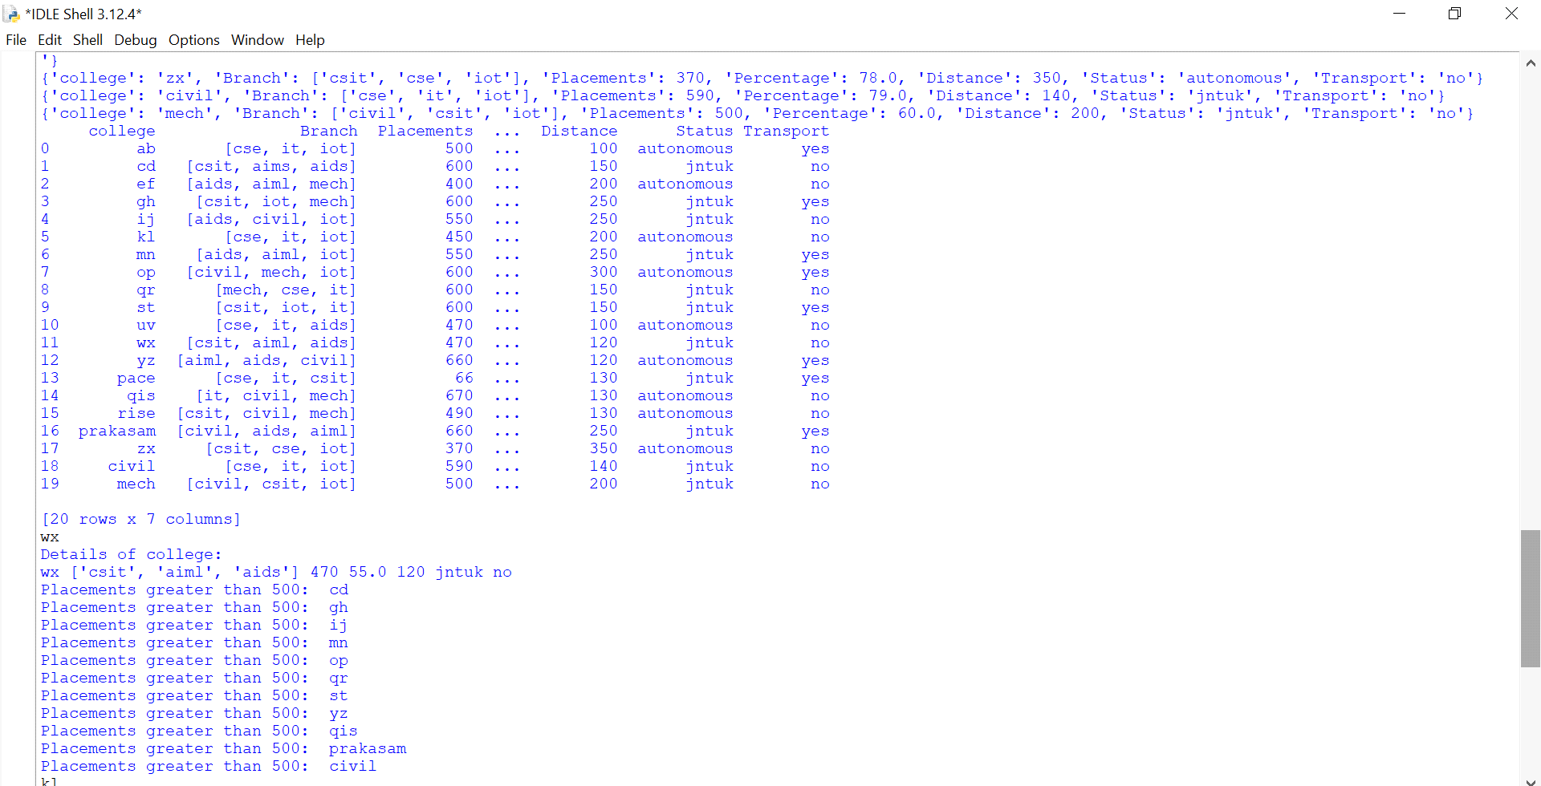

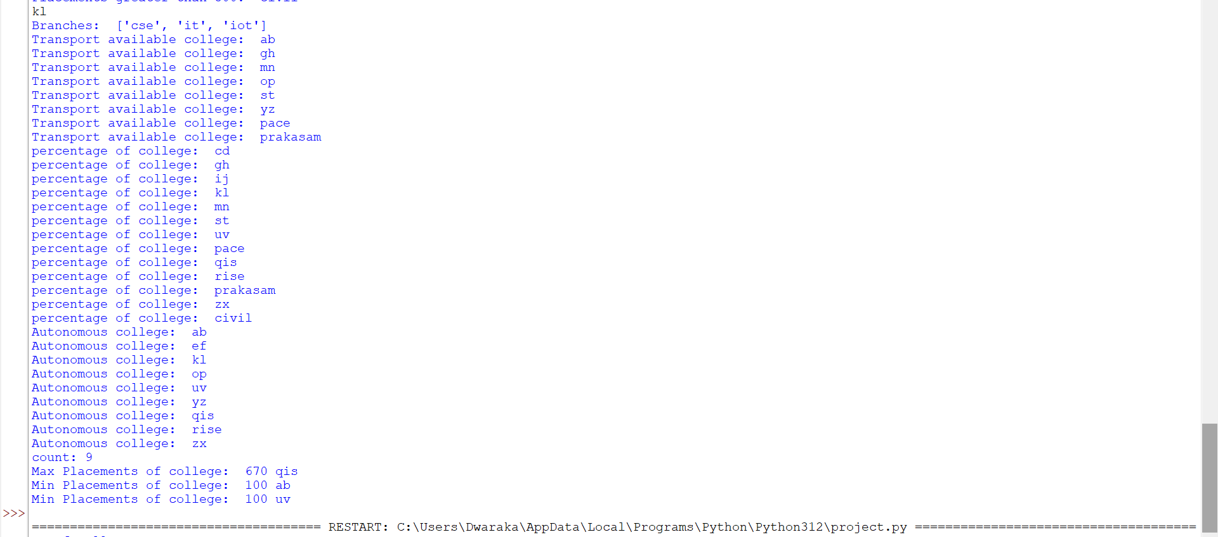

Conclusion:- The provided code enables the management and analysis of college data through user input and basic data manipulation techniques. It allows users to input details for multiple colleges, store them in a structured format, and perform various analyses such as finding colleges with high placements, available transport, or high pass percentages.

Additionally, it provides functionality to extract specific information about individual colleges, such as their branches or placement details. Finally, it offers summary statistics such as the count of autonomous colleges, the college with the maximum placements, and the college with the minimum distance.